Bank Configuration Portal Deployment’s Manual

Summary

This manual guides users through deploying an ASP.NET MVC 5 project using IIS. It covers publishing the project folder, configuring IIS virtual account read/write permissions for the database, and setting up the IIS configuration.

Publish MVC5 Project folder

- Open solution’s folder in visual studio then right click on the mvc5 project folder named “WebPortal.ASP” choose Publish option.

- Choose Folder then press Next.
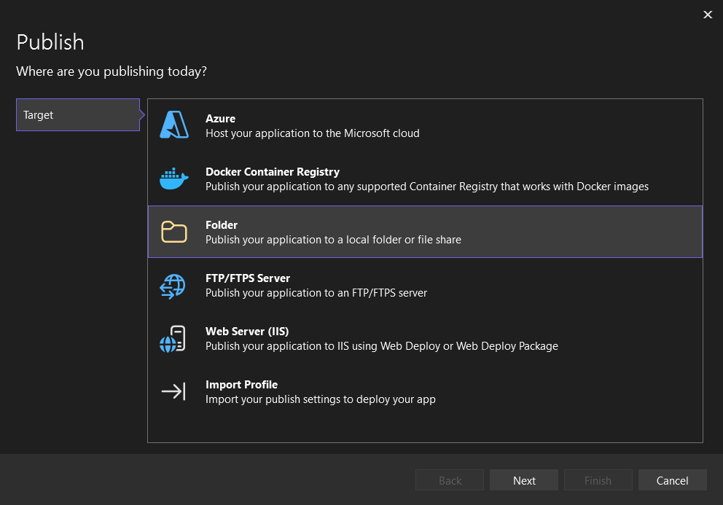

- Define any file path you prefer. To avoid permission issues, choose a location outside of the C:/Users folder.

- After finishing setting the publish folder up press on publish button on top right corner.

- It must show Publish succeeded message

Setting up connection string

- Navigate to the published root folder of the project and open the web.config file.

- You have two options either use SQL server authentication when we want to use a user ID and a password and the database is on a different domain or outside our local network, or Windows authentication if we want to use windows login info and the database is on the same network domain or local network.

- If Windows Authentication is chosen: Update the template string by providing your server name (Data Source) and database name (Initial Catalog) directly after their respective equals (=) signs, and ensure Integrated Security=True is included. Do not add spaces, usernames, passwords, or alter the template structure. Copy the resulting string and paste it into the quotes of the connectionString attribute inside your web.config file.

  - “Data Source=;Initial Catalog=;Integrated Security=True;Current Language=English;”

- If SQL Server Authentication is chosen: Update the template string by providing your server name (Data Source), database name (Initial Catalog), username (User ID), and password (Password) directly after their respective equals (=) signs. Do not add spaces or alter the template structure. Copy the resulting string and paste it into the quotes of the connectionString attribute inside your web.config file.

  - “Data Source=;Initial Catalog=;User Id=;Password=;Current Language=English;”

- Make sure that result connection string is not nested in double quotation like this “” “”.

- Save your changes and ensure no XML tags or required information were accidentally modified or deleted.

Setting up project’s IIS deployment.

- Open IIS through searching IIS in windows search.

- Right click on Sites and choose Add website.

- Enter your preferred name in the Site name field.

- Fill the physical path with the root direction of the published folder from before.

- Enter an unassigned port number that is not currently in use by other websites or reserved by the system. It is best to choose a custom port within the range of 1024 to 65535.

- Entered your preferred name in the host name field.

- Press Ok

Granting Database Permissions to the IIS Virtual Account

- These steps are required when using Windows Authentication. Because the system authenticates connections using the application identity, you must create a SQL Server login for your IIS Application Pool and grant it the necessary database privileges.

- Open SQL Server Management Studio.

- Open a new query in SQL Server Management Studio (SSMS) and paste the SQL script. Locate the backslash (\) characters in the script and append your exact IIS Application Pool name immediately after them. To avoid mismatches, copy the pool name directly from the Application Pools menu in IIS Manager. Ensure no trailing spaces or formatting changes are introduced.

CREATE LOGIN [IIS APPPOOL\] FROM WINDOWS
GO
ALTER SERVER ROLE [dbcreator] ADD MEMBER [IIS APPPOOL\]
GO
- Press Execute.

- Expand Security inside the required server then expand Logins search for the newly created login it should start with IISAPPPOOL\”your site name” if not right click on Logins and press refresh.

- Right click on this specific login and choose properties then choose User mapping.

- Choose the Dedicated database Check its column map and check both db_reader and db_writer in database role membership for the database you chose then press Ok.

- Check the user’s manual in order to know how to use the application

